**MCA 306 ADVANCED OPERATING SYSTEM LAB USING LINUX**

**MCA 2023-SEMESTER 3**

**LIST OF EXPERIMENTS-LAB CYCLE 1**

1. Create a Directory Structure to help the library organize its books better. child nodes are directories.

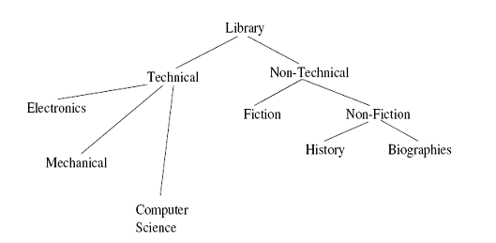

|  |
| --- |
| Do the following operations in the above directory structure.   1. You want to read BenjaminFranklin.txt one page at a time. How?(create it in hisory Dir) 2. create a file named labrules in computer science and copy the same to directories electronics and mechanical. 3. copy all c files into another directory called lab in computer science |
|
|
|
|
|
|
|
|
|
|
|

1. Do the following operations in Linux
2. Obtain the following results
3. To print the name of operating system
4. To print the login name
5. To print the host name
6. Find out the users who are currently logged in and find the particular user too.
7. Display the calendar for
8. Jan 2000
9. Feb 1999
10. 9th month of the year 7 A.D
11. For the current month
12. Current Date Day Abbreviation , Month Abbreviation along with year
13. Display the time in 12-Hour and 24 Hour Notations.
14. Display the Current Date and Current Time.
15. Display the time as HH:MM:SS(AM/PM)
16. Display the current day in abbreviated form
17. Directory Handling Commands
18. Display the name of your home directory.
19. Display all files including hidden files
20. Create a directory TEST
21. Using a single command change from current directory to home directory.
22. Remove a directory using absolute pathname.
23. Create files myfile and yourfile under Present Working Directory.
24. Display the files myfile and yourfile.
25. Append more lines in the myfile
26. Copy myfile file to another file "emp"
27. Move yourfile file to another directory
28. Display the number of words , lines and characters in myfile
29. Display the words ending with a ,b or c in yourfile
30. Compare a myfile with itself.
31. Compare myfile file and your file.
32. remove a directory with files by using a single Command.
33. Rename myfile as "DATA"
34. Copy DATA to another directory by name TRIAL.
35. Perform the following operations
36. Create a file **timefile**
37. Display all the lines which contain the word “time”.
38. Display the lines that do not have the word “time”
39. Get a count of the number of such lines.
40. Save all the lines having the word “time” in another file called “TimeFile.txt”
41. Do the following
42. Create a file ‘marklist’ and store the name and five marks of three students. [ENG,HINDI,SCIENCE,EVS,MATHS]
43. Display the details of last 2 students
44. Display the details of 3rd student
45. Display the marks of ENG only
46. Display the marks of ENG and MATHS
47. Perform the following operations
48. Create a directory “MYFILES”
49. Move to the directory and create some files in it
50. List names of all files beginning with the character ‘P’ on the screen and also store them in a file called P_files.
51. Display the list of files for which owner have read permission in the MYFILES directory.
52. Perform the following operations
53. Create a file ‘sample’ of names
54. Check for the word ‘ram’
55. sort the file
56. find repeated names
57. sort the files in descending order and copy to another file ‘desc’
58. Do the following
59. Create files ‘student’ and ‘staff’
60. Combine the two files to a third file ‘people’
61. Sort the file ‘people’
62. Squeeze the multiple occurance of space in the file ‘people’
63. Change the the name “ANU” to “AMAYA” in ‘people’
64. Do the following
65. Create a file ‘friends’
66. Write the full names of your friends to the file (min 10 names)
67. Display only first names and save to another file ‘first_name’
68. Display firstname and middlename only.
69. Display the name of last 3 friends
70. Assume the contents of file emp as

|  |  |  |  |  |  |
| --- | --- | --- | --- | --- | --- |
| Emp No | Name | Designation | Department | DOB | Salary |
| 2334 | sharma | gm | sales | 12/12/02 | 6000 |
| 1234 | sumit | director | production | 19/02/54 | 4500 |
| 4538 | karuna | dgm | personnal | 31/07/58 | 3200 |
| 2586 | argarwal | manager | marketing | 17/11/62 | 6800 |
| 5465 | saxena | executive | marketing | 18/12/40 | 9000 |

1. To list the details of employees having designation as gm and dgm
2. To extract details of the employees name only
3. To display the first three records of the file